

Business intelligence and visualization.

By;

Name: **Prajwal.jagadish**

Student no: 10595832

**1**

**CONTENTS**

1. Introduction 1
   1. Reasons for selecting the subject area AND DATA 2
   2. Vision and Goals 2
   3. Key StakeHolders 2
   4. Business requirements 2
   5. Any other sections 2
2. Dimensional Model 2
3. ETL to Popuplate the Data WareHouse / Data Mart 4
4. Visualisations 5

TABLEAU Visualizations 5

1. Customer churn visuals 6

BIBLIOHGRAPHY **Error! Bookmark not defined.**

LINK TO DATA SETS

[Sample Data Sets | Tableau Server Guru (wordpress.com)](https://tableauserverguru.wordpress.com/sample-data-sets/)

1. INTRODUCTION

The concept of business intelligence makes effective use of various practices, tools and technologies for collection of raw data and efficient analysis. These actionable insights are organized and presented to make better business decisions. In this project two different data sets are used to get an overview of SQL server and visuals from the tool Tableau. The first data set is based on car sales analysis. The car sales data is analyzed from SQL server management tool and is populated into the database with the help of visual studio and SQL-server integration services (SSIS). These are then populated to database. With this regard, car sales information is taken to understand and implement better decision for auto business. The second dataset is about customer churn in telecommunication industry. The churn prediction is shown due to which different factors are influenced to churn the contract of the customer. The first part explains about car sales analysis. However, the analysis and visuals are implemented in which a company can take calculated risk according to the factors influencing the decision making.

**2**

* 1. REASONS FOR SELECTING THE SUBJECT AREA AND DATA
* Online customer engagement and sales
* Dealership management.
* Network consolidation to match demand.
* Reduced profits for parts servicing electric vehicles with fewer moving parts.
* New types of finance and transportation-as-a-service.
  1. VISION AND GOALS
* To acquire essential business metrics rapidly to facilitate accessibility for business data to all the employees in the company.
* Removes the need for speculation – Dealership reputation is always at stake.
* Valuable insights into customer behavior through data analysis and identification of risk.
  1. KEY STAKEHOLDERS

The key stakeholders are: Top level management and Dealership owners.

1.5. BUSINESS REQUIREMENTS

Auto dealers are responsible for their products and branch.

1.6. ANY OTHER SECTIONS

1. **DIMENSIONAL MODEL**

The car_sales data set contains 4 dimensions, where revenue table is considered as fact table which contains foreign keys of dealer, model, branch and date tables. The relationships is modified according to the requirements of car dealerships and effectively focused on total revenue and units sold in different branches.

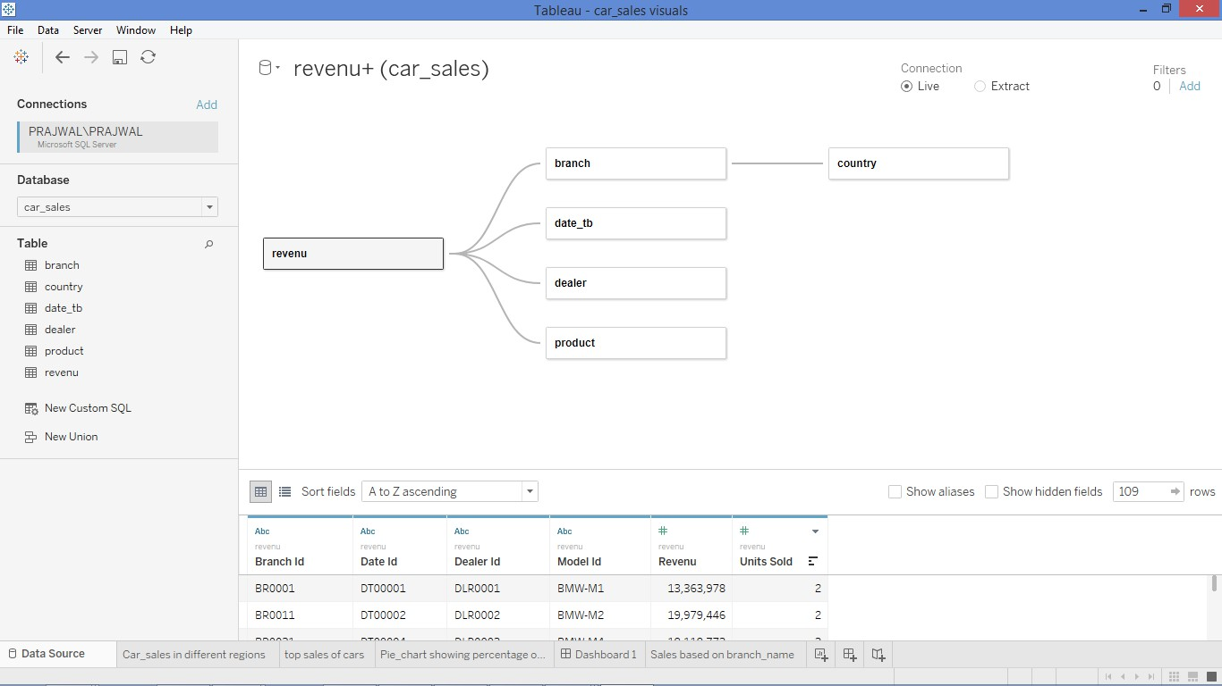

**3**

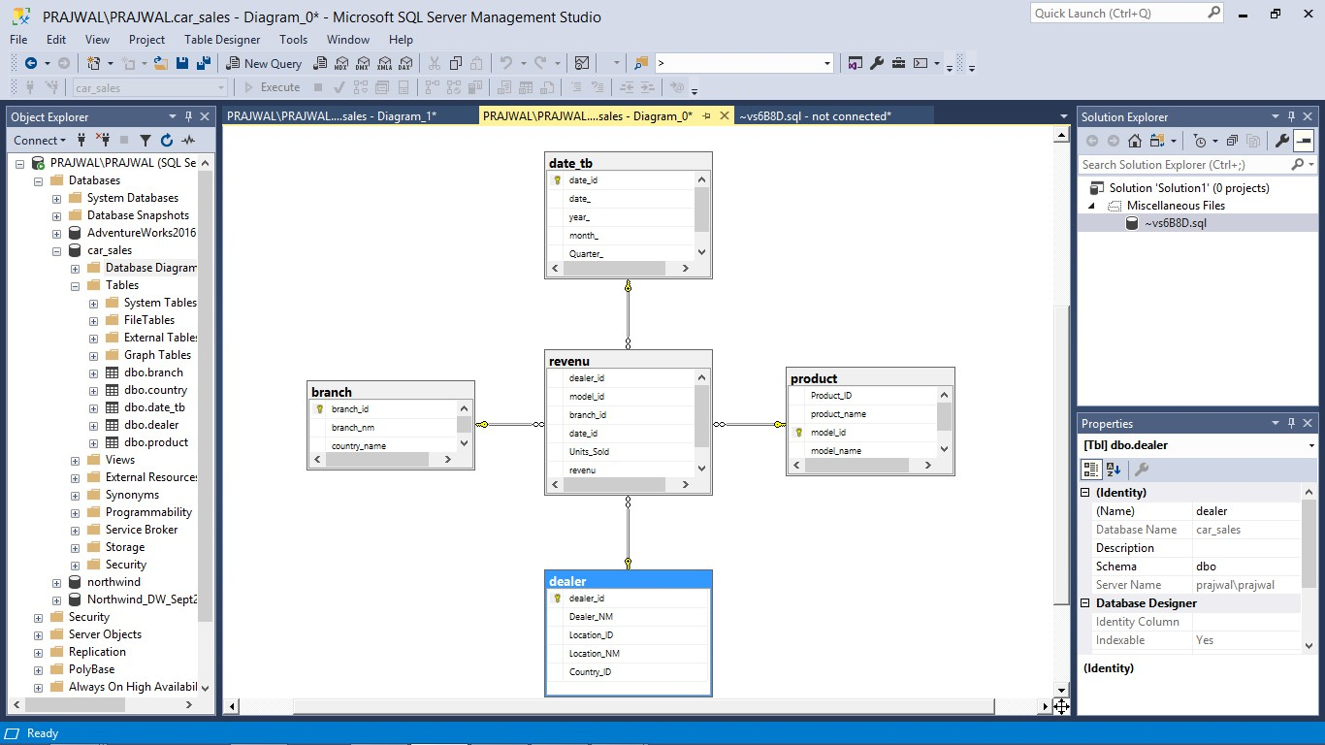

**4**

The above diagram shows the relationship of the fact_table. The revenue table is the fact table which is associated with other 4 dimensions. The branch table have the country names which lead to identify branches situated in different countries. However, these are connected with the help of primary and foreign keys.

**4. ETL TO POPUPLATE THE DATA WAREHOUSE / DATA MART**

Truncate: ensures old data stored are deleted in tables and new data are added to the database.

Extraction: In this project, extraction process was challenging due to cleaning of data and ensuring the sequence of data.

Transform: The unwanted data were cleaned and modified with business requirements. Each variable are important because they are interrelated to each other.

Load: In the last step of the ETL process, the data were loaded to databases. All the data were transferred from flat file to OLE DB with the help of data flow task in SSIS, as this file was CSV.

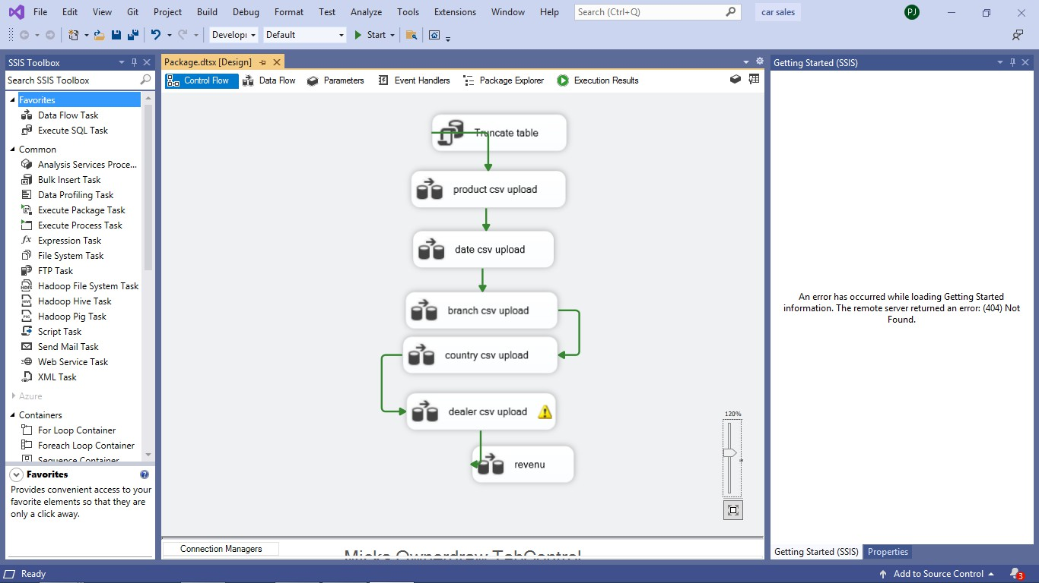

**5**

The above Diagram explains ETL process and about SSIS package where 4 different dimensions are configured. The data is populated with the data source of flat file extension and is dragged to OLE DB destination where all the data is populated. The Flat file data source was used because data is present in the form of CSV file.

1. **VISUALISATIONS AND REPORTS**

4.1. TABLEAU VISUALIZATIONS

The Tableau visuals is imported through Microsoft-SQL-server, then the data source contains the relationship diagram which help to join different variables that impacts the process.

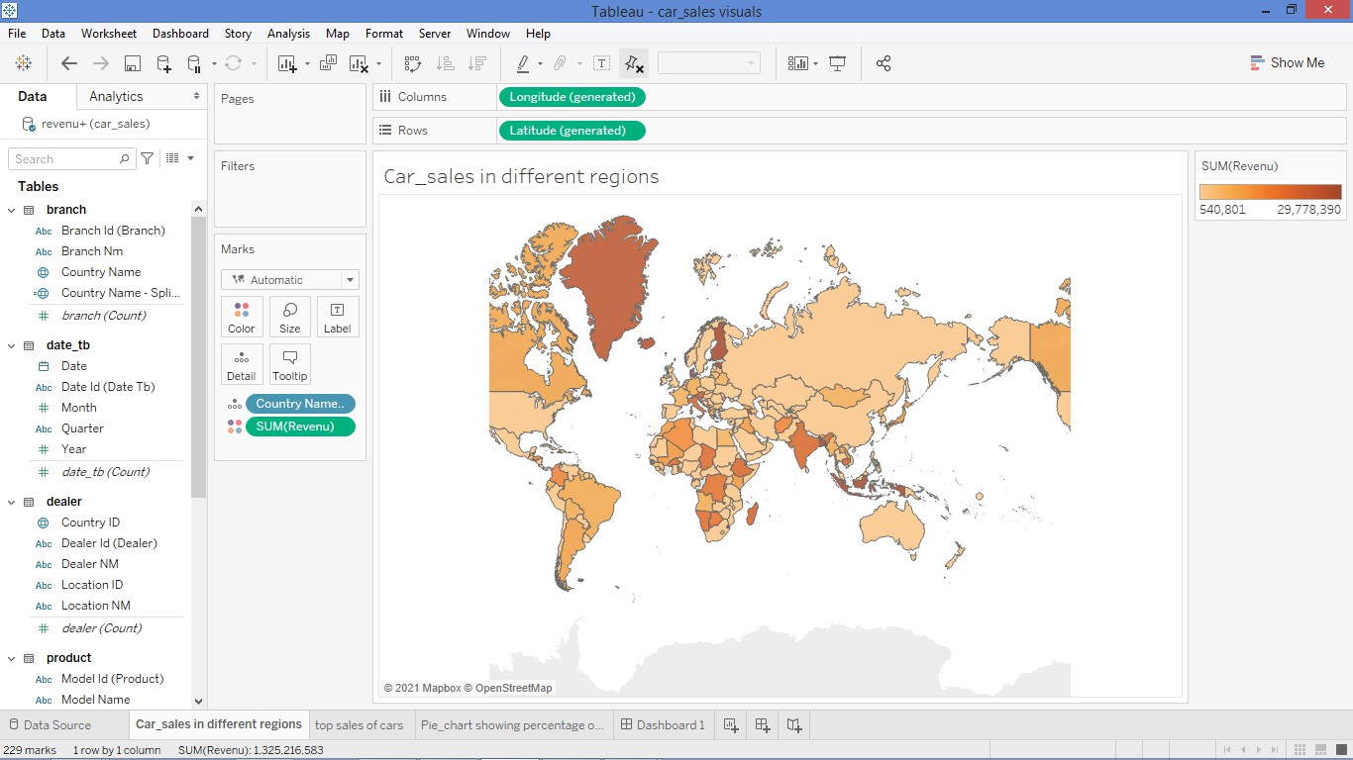

The above visualization describes about the total revenue in different countries. The dark orange color shows the highest revenue and lighter orange shows the lesser sum of revenue. However, this provides an overview for the sales in the whole world, as this feature is effective for international trade.

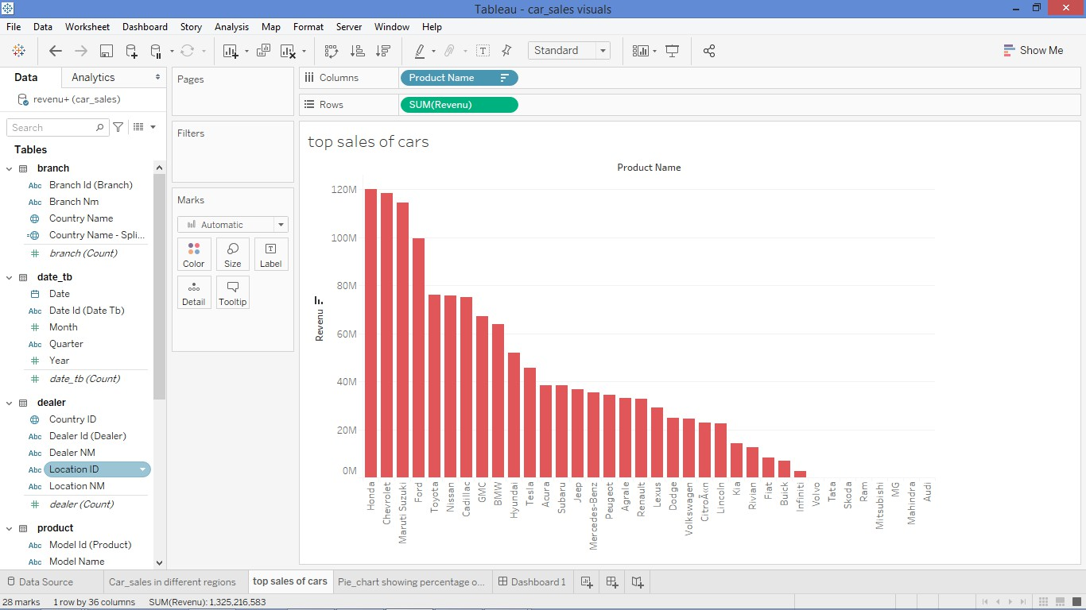

**6**

The Visualization shows top sales of cars with respect to total revenue. The top 5 cars which stood out are Honda, Choverlet, Maruti Suzuki, Ford and Toyota. This also describes which dealership is better according to the brand.

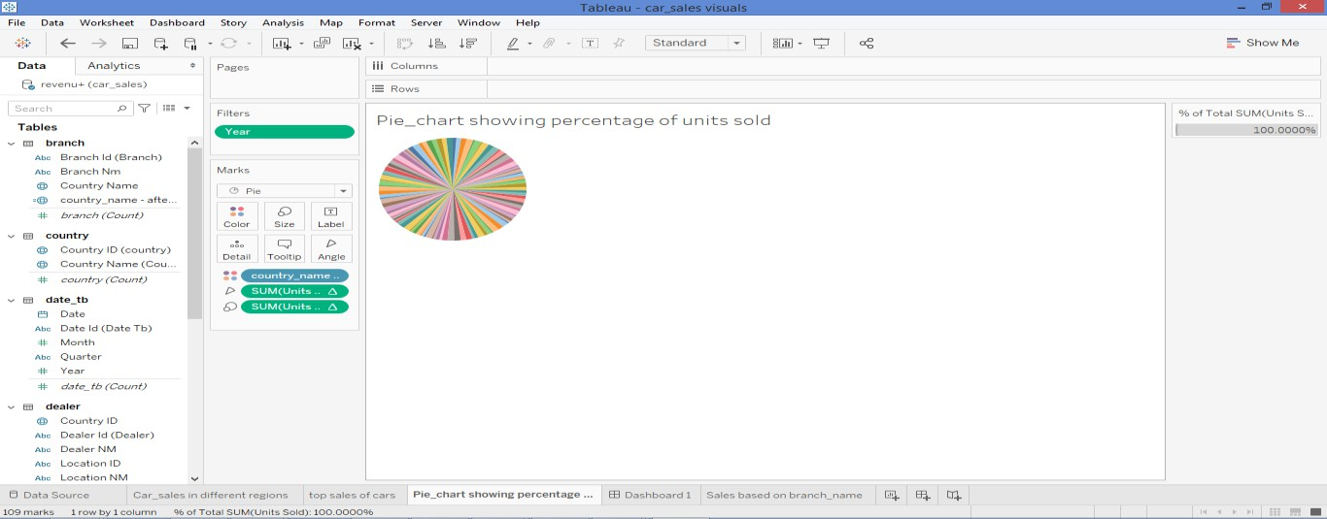

This pie chart describes about the units sold in different countries. This sums upto 100% of units sold in different countries. In this analysis, we can understand many countries have participated in sales of car as every country showing a small margin of units sold.

**5. CONCLUSIONS**

The above business intelligence technique provides a platform for the dealers to know profits generated customer behavior and dealership management all over the world. This helps every dealer to make better decisions with respect to sales and information generated through different reports. Therefore, car sales provided different information to make better decision in all the aspect and dimensions.

**7**

**Data set 2 :Customer churn**

In developed countries, telecommunication sector is one of the important industries. In this competitive world industries are thriving hard to survive through implementing various strategies. Operators and technical progress have increased the level of competition in telecommunication industry. In customer churn, it is divided into two groups – (i) accidental churn: the conditions of a company keeps changing with regard to policies and standards, this creates a customer to adopt or change according to the utilization of services. For instance, the benefit of cost increases unreliably, that impacts customer to churn. (ii) Intentional churn: this happens when clients shift from one company to another that gives better services, cost- friendly, and ideas from the competitors. With regard to Telecommunication Company, the key factor is to generate revenues and up-sell the existing customers. The operators and technical members must identify clients before they exit from the company. However, these business intelligence tools have made easier to better decision based on customer factors influencing to churn.

The data set is collected via web search of Reliance Company; the data set includes 7043 records with 21 variables. The data set contains following information:

* Customers enrolled for different services and subscriptions: internet service, online security, online backup, streaming movies and TV, tech support and phone services.
* Exit of customers: the column name is Churn.
* Information about customers: Payment methods, monthly charges, total charges, paperless billing and Contract of the customer.
* Demographic information: Partners (dependents), gender, and senior citizen.

Therefore, the data is imported from CSV file that is text_file in tableau.

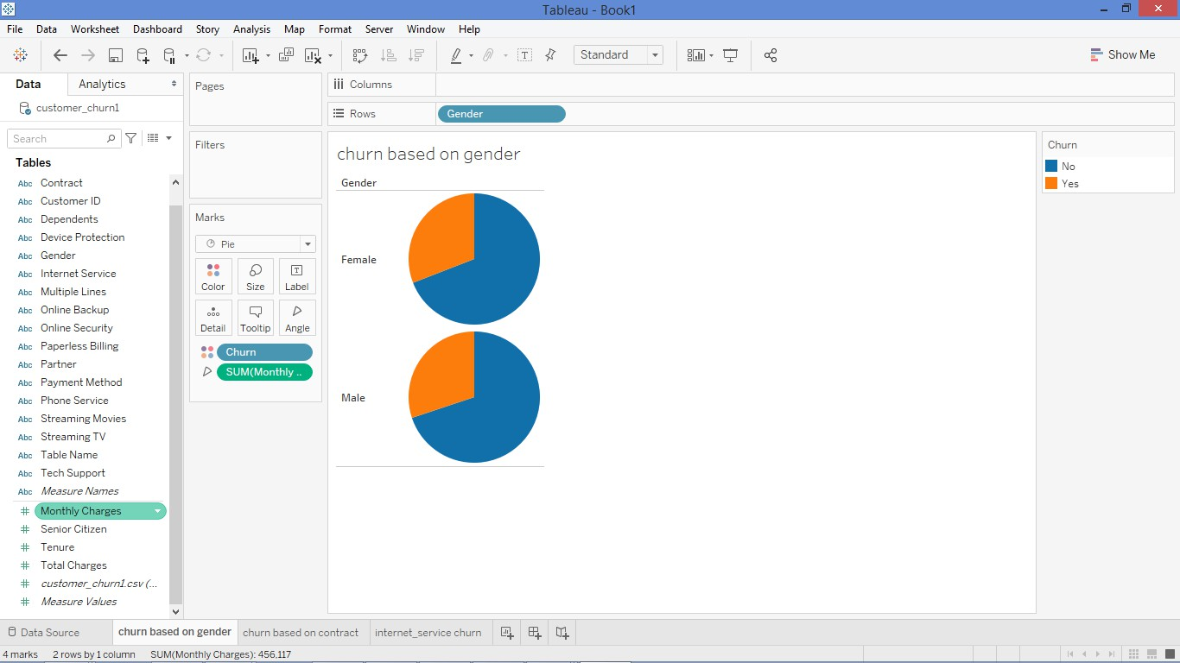

**8**

The above pie chart explains about customer churning according to gender. By this analysis we can conclude, there are equal number of churning customers with regard to both the genders. The number of customers churning the contract is less. However, this analysis provide good sign for the telecommunication industry to implement same strategy, in which monthly charges is impactful in the whole process.

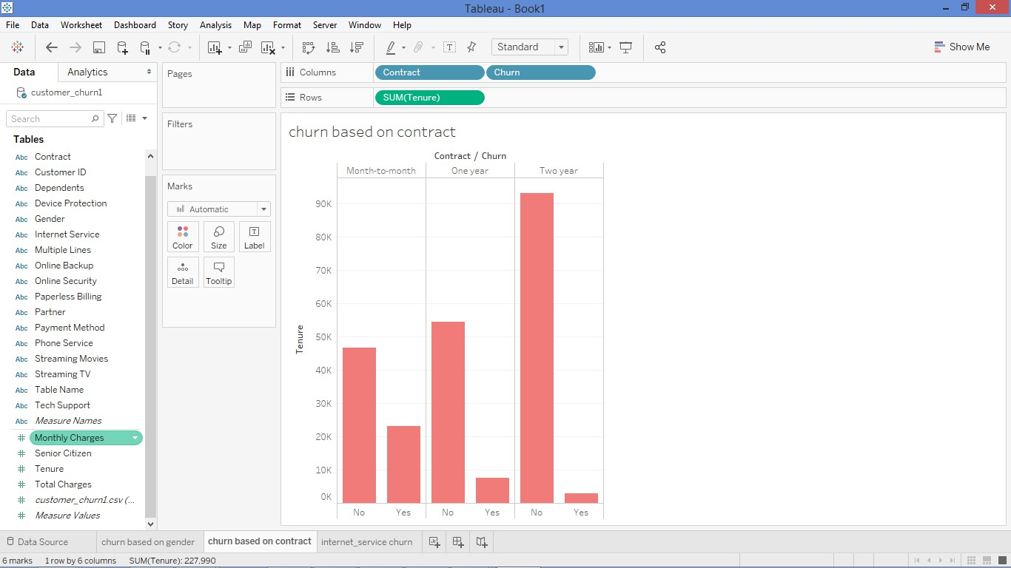

The above bar graph describes according to the tenure provided to the customer. The contract is monthly, one year and two year tenure. This explains customer who chooses two-year contract churns less. This in-turn means total charges for two years are less compared to short term charges. However, the decisions taken from this analysis are vital for the company to enhance more benefits from loyal customers.

**9**

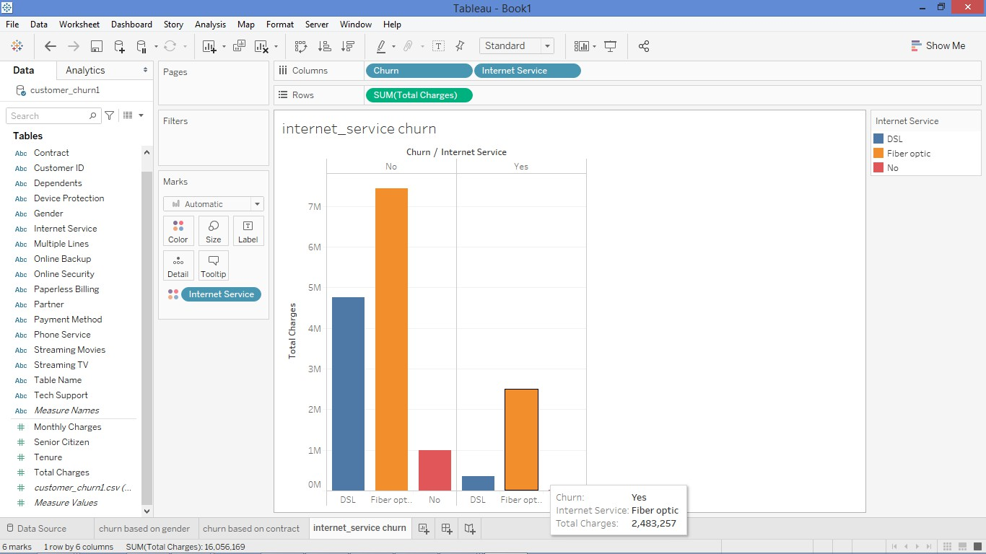

The above diagram explains about two features that are internet service and total charges. The customers who choose fiber optical service tend to stay in the contract rather than DSL or NO internet service. This impacts the process of internet providing by the telecommunication industry to enhance more on fibre optical, which helps them to retain valuable customers in the market.

**Conclusion:**

The business intelligence platform and data visualization provides effective insights for a company to make better decisions. The efficiency of the company also increases through analysis of various risk factors. Therefore, the above examples have proven the process of data analysis.